Preliminary, January 2022

**A Quantile Study of Two Covid-19 Years: Accounting for Countries’ Heterogeneity**

by

Joshua Aizenman, Alex Cukierman, Yothin Jinjarak and Weining Xin

This paper takes stock of the remarkable heterogeneity of countries’ Covid-19 experience during the first two Covid years, 2020-2021. We start with two benchmark dynamic panel regressions using local projections (Jordà [2005](https://link.springer.com/article/10.1007/s41885-020-00071-2#ref-CR17)), explaining the weekly *official covid mortality* *growth rates* over time and across countries during the first Covid year, 2020, and the second, 2021. The choice of these two-sub periods reflects the presumption that the arrival of vaccines in early 2021 may induce a game changer of Covid dynamics. Figure 1 reports cumulative vaccine doses/100 people; vividly showing that vaccination rate was almost zero in January 2021, reaching above 160/100 in the upper-middle and high income by December 2021, about half of this level in the lower-middle income countries and about tenth in the low-income countries (about 15/100).

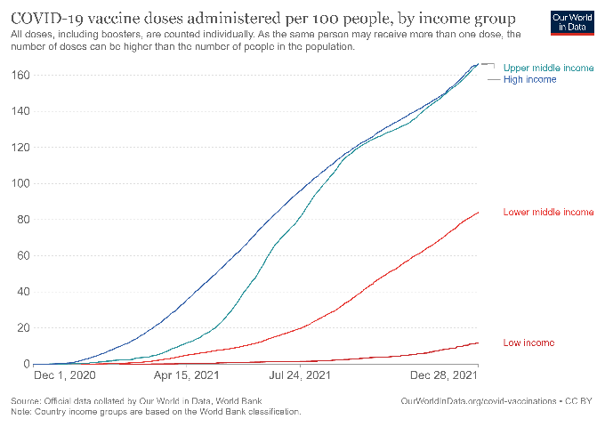

Figure 1: Vaccine doses/100 during 2021

Our focus on mortality growth rates is in line with the epidemiological SIR pandemic Model, pioneered by Kermack et al. (1927) and extended into a stochastic model by Kendall (1954). The SIR framework partitions the population’s exposure to the pandemic into three sub-groups: ***S***usceptible, ***I***nfectious, and ***R***ecovered or ***R***emoved by gaining immunity or death, respectively. The transitions between the three sub-groups are governed by pandemic’s virality interacted with the average contacts per unit of time between the *S* and *I* sub-groups; and by the odds and speed of recovery and gaining immunity or death of a person in sub-group *I*; and the size of each sub-groups, the arrival of new variants, immunity duration, and the like.and by the odds and speed of recovery and gaining immunity or death of a person in sub-group *I*; and the size of each sub-groups, the arrival of new variants, immunity duration, and the like.

The baseline version of the SIR model predicts an exponential infection process that changes dynamically during pandemic stages, first accelerating, down the road reaching an inflection point and decelerating and approaching herd immunity, following a logistic curve.  This prediction should be taken with a grain of salt -- it holds as long as the key parameters are constant, and death and birth rates are of second-order magnitude. Some of these issues were dealt with more effectively by Kendall (1954).Some of these issues were dealt more effectively by Kendall (1954).

In practice, pandemics have a profound influence on human behavior: fear, reduced mobility and contacts, adaptation and isolation, new policies and policy fatigue, and the like. These behavioral changes, the arrival of new variants and vaccinations, and other shocks induce more complex pandemic cycles. This has been vividly illustrated by Acemoglu et al. (2021). They constructed the SIR modelof Covid-19 with targeted lockdowns in a multi-group setting where infection, hospitalization, and fatality rates vary between demographic groups, illustrating the importance of population and policy heterogeneity in degerming the pandemic patterns, and thereby pandemic’s economic costs. They find that optimal policies differentially targeting risk/age groups significantly outperform optimal uniform policies and most of the gains of lower Covid mortality and higher livelihood can be realized by having stricter lockdown policies on the oldest group. They find that optimal policies differentially targeting risk/age groups significantly outperform optimal uniform policies and most of the gains of lower Covid mortality and higher livelihood can be realized by having stricter lockdown policies on the oldest group.

In line with these developments, our benchmark regressions control for three pandemic variables (lagged weekly new mortality, total vaccination per 100 people, and total ***R***ecoveries per million people); binary interacting these variables with each other’s; and interacting each of the three variables with demographic factors (population density, urban population share, Aged 65+ population share); governance and economic factors (GDP/Capita, Government effectiveness); and geography (latitude, longitude).

Some international evidence suggests that the ratio of current mortality to lagged infects is decreasing in the total number of vaccines per hundred individuals (Aizenman et al., 2021). Using a large set of controls, we conducted a Chow test rejecting the hypothesis of benchmark regressions’ stability between 2020 and the 2021 sub-sample. This result is in line with the probable structural break between the first and the second Covid year, possibly triggered by the arrival of vaccinations. Figure 2 reports the daily new confirmed Covid deaths per million people, using a linear scale in the left panel, and a log scale in the right panel. The log scale chart suggests that for the high and upper and lower middle income, countries with more prevalent vaccinations by mid-2021 experienced also a reduction of the slopes of the new confirmed Covid deaths per million people during the second half of 2021.

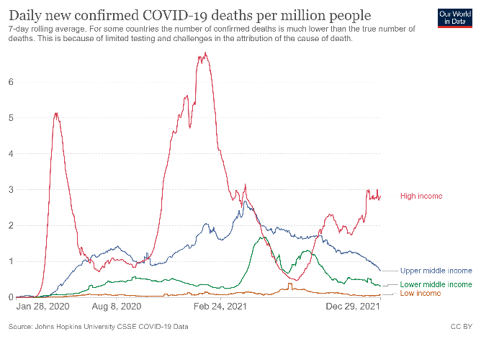 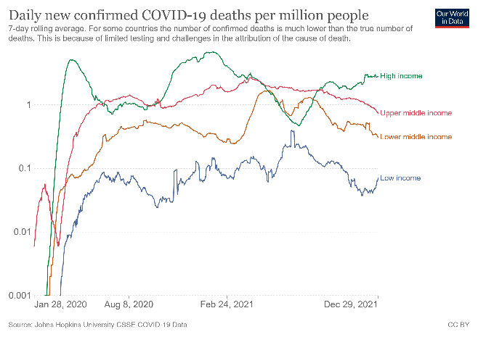

**Figure 2:** Daily confirmed Covid-19 mortality per-million [linear scale, left panel; log scale, right panel], High income, lower-middle, and upper-middle and high income.

Henceforth, we do not pool 2020 and 2021 together in our subsequent analysis. The main benchmark regressions’ results are: **TBA**

For robustness varication, we replicate the two baseline regressions accounting for excess mortality rates. The main results are TBA

Next, we investigate Covid’s heterogeneity across countries and time, and the degree to which countries’ quantile ranking switches between the first and the second Covid years.

**TBA and updated** Table 1 reports cumulative confirmed Covid mortality/capita quartiles (henceforth CMQ), ordered from the lowest to the highest at the end of the sample period. Panel 1a provides the countries’ average statistics of each quartile, Panel 1b reports the countries in each quartile [**Weining**, **please add to the statistics the average cumulative mortality/million for each bin, and order the countries by their average cumulative mortality/million for each bin, from the lowest to the highest**].

On average, higher GDP/capita countries experienced higher cumulative mortality. The average GDP/capita of the highest CMQ exceeds the average GDP/capita lowest CMQ by a factor of 2.3 (10,700 $ versus 24,200 $). This suggests that higher income by itself does not help in resolving the pandemic tragedy of the commons’ challenges.[1] The CMQ gaps between the lowest and the highest quartiles are enormous, **X** versus [2], respectively.

On average, countries in higher CMQ quartiles are characterized by a higher population share of senior citizens, a higher urbanization rate, and being further away from the equator. These observations are in line with the growing literature on factors accounting for Covid-19’s dynamics. Yet, these factors don’t explain the bulk of the heterogeneity across countries. To illustrate, the lowest CMQ includes mostly low-income countries, but also emerging markets like China, and affluent countries like South Korea, Singapore, Australia, and New Zealand. A fair share of cumulative mortality is accounted for by the interaction between the given structural factors [demographics, urbanization, and other geographic features] with shifting behavioral, medical, non-pharmaceutical interventions (NPIs), and policy factors. These shifting factors include the arrival of new Covid variants, the gradual diffusion of vaccinations, the effectiveness of stringency and containment policies, improvements in medical treatments, growing Covid-19 fatigue, increasing share of the population gains greater immunity either by vaccination or after recovering from the infection, and other fast-moving changes. While structural factors changed little during the pandemic, tracking and controlling for the shifting factors is a major empirical challenge.

To gain further insight on the heterogeneity of countries in Covid times, we apply a quantile panel regression design, testing whether the explanatory power of key variables differs across quantile, and changes over time.

Table 1a, Cumulative Confirmed Covid Mortality per million up to December 2020 within each Quartile, average countries’ statistics

|  |  |  |  |  |
| --- | --- | --- | --- | --- |
|  | **1st Quartile (Lowest Cum. Mortality)** | **2nd Quartile** | **3rd Quartile** | **4th Quartile (Highest Cum. Mortality)** |
| Population | 70766427.2 | 40688758.8 | 58053549.6 | 38082570.4 |
| Population Density | 353.1 | 321.7 | 188.2 | 103.2 |
| Urban Population Share | 42.6 | 57 | 70.7 | 72.1 |
| Aged 65+ Population Share | 4.7 | 6.2 | 9.2 | 14.9 |
| Cardiovascular Disease Death Rate | 269 | 298.3 | 268.9 | 211.2 |
| Diabetes Prevalence | 6.4 | 6.8 | 9.1 | 6.9 |
| GINI Index | 40.5 | 39.2 | 36.1 | 36.7 |
| GDP per Capita | 7850.5 | 14287.2 | 24412.8 | 26506.9 |
| Health Expenditure | 276.3 | 791.8 | 1155.5 | 2128.7 |
| Life Expectancy | 65.7 | 69.5 | 75.6 | 78.2 |
| Rule of Law | -0.5 | -0.5 | 0 | 0.4 |
| Voice and Accountability | -0.6 | -0.5 | -0.2 | 0.6 |
| Government Effectiveness | -0.5 | -0.5 | 0.1 | 0.5 |
| Latitude | 4 | 11.3 | 31.8 | 31 |
| Longitude | 42.1 | 31.7 | 12.2 | -7.4 |

Table 1b, Cumulative Excess Mortality per million up to December 2020 within each Quartile, average countries’ statistics (top panel), Countries’ list (bottom panel)

|  |  |  |  |  |
| --- | --- | --- | --- | --- |
|  | **1st Quartile (Lowest Cum. Mortality)** | **2nd Quartile** | **3rd Quartile** | **4th Quartile (Highest Cum. Mortality)** |
| Population | 62211151.9 | 24275846.3 | 80116128 | 39194423.7 |
| **Population Density** | **356.1** | **317** | **179.2** | **100.6** |
| Urban Population Share | 55.3 | 58.2 | 59.2 | 66.2 |
| **Aged 65+ Population Share** | **7.8** | **6.5** | **7.9** | **12.7** |
| Cardiovascular Disease Death Rate | 242.6 | 262.9 | 273.6 | 270.9 |
| Diabetes Prevalence | 6.9 | 6 | 8.2 | 7.9 |
| GINI Index | 39.2 | 39.4 | 39.2 | 34.8 |
| **GDP per Capita** | **20000.6** | **14233.8** | **18255.6** | **20856.1** |
| Health Expenditure | 1214.8 | 745.1 | 1259.5 | 1152.7 |
| Life Expectancy | 71.1 | 69.6 | 72.1 | 76.2 |
| Rule of Law | 0.1 | -0.3 | -0.3 | -0.1 |
| Voice and Accountability | 0 | -0.4 | -0.3 | -0.1 |
| Government Effectiveness | 0.2 | -0.4 | -0.2 | 0.1 |
| Latitude | 9.8 | 14.3 | 18.1 | 36.2 |
| Longitude | 49.7 | 10.7 | 15.8 | 6.1 |

Table 2a, Cumulative Confirmed Covid Mortality per million up to December 2021 within each Quartile, average countries’ statistics (top panel), Countries’ list (bottom panel)

|  |  |  |  |  |
| --- | --- | --- | --- | --- |
|  | **1st Quartile (Lowest Cum. Mortality)** | **2nd Quartile** | **3rd Quartile** | **4th Quartile (Highest Cum. Mortality)** |
| Population | 66246385.5 | 72137531.6 | 27555946.7 | 37762631.6 |
| **Population Density** | **278.6** | **390.4** | **185.7** | **89.9** |
| Urban Population Share | 42.9 | 55.5 | 68.6 | 69.6 |
| Aged 65+ Population Share | **4.1** | **6.7** | **9.1** | **14.6** |
| Cardiovascular Disease Death Rate | 313.4 | 257 | 244.9 | 242.5 |
| Diabetes Prevalence | 5.9 | 7.5 | 8.3 | 7.2 |
| GINI Index | 41.2 | 36.5 | 38 | 36.3 |
| **GDP per Capita** | **5310.4** | **20590.6** | **24297.7** | **22234.7** |
| Health Expenditure | 177.9 | 973.9 | 1714.1 | 1429.8 |
| Life Expectancy | 64.6 | 71.1 | 75.7 | 77.3 |
| Rule of Law | -0.7 | -0.2 | 0.1 | 0.2 |
| Voice and Accountability | -0.8 | -0.5 | 0 | 0.5 |
| Government Effectiveness | -0.8 | -0.1 | 0.2 | 0.3 |
| Latitude | 8.1 | 13.5 | 27.4 | 29.2 |
| Longitude | 28.5 | 47.8 | 19.4 | -8.4 |

Table 2b, Cumulative Excess Mortality per million up to December 2021 within each Quartile, average countries’ statistics (top panel), Countries’ list (bottom panel)

|  |  |  |  |  |
| --- | --- | --- | --- | --- |
|  | **1st Quartile (Lowest Cum. Mortality)** | **2nd Quartile** | **3rd Quartile** | **4th Quartile (Highest Cum. Mortality)** |
| Population | 55790460.9 | 36315592.6 | 42391243.5 | 68018586.5 |
| Population Density | 530.1 | 122.2 | 182.7 | 116.7 |
| Urban Population Share | 63.3 | 48.4 | 66 | 60.2 |
| Aged 65+ Population Share | 8.8 | 6.2 | 9.1 | 10.7 |
| Cardiovascular Disease Death Rate | 236.9 | 268.3 | 233.8 | 315 |
| Diabetes Prevalence | 7 | 5.7 | 8.1 | 8.1 |
| GINI Index | 37.4 | 39.8 | 38.9 | 35.8 |
| GDP per Capita | 25293 | 11369.8 | 20820.5 | 15622.5 |
| Health Expenditure | 1600.7 | 942.7 | 1371.8 | 471.3 |
| Life Expectancy | 72.7 | 67.8 | 74.7 | 73.6 |
| Rule of Law | 0.3 | -0.5 | -0.1 | -0.3 |
| Voice and Accountability | 0.1 | -0.5 | -0.1 | -0.3 |
| Government Effectiveness | 0.3 | -0.4 | 0 | -0.2 |
| Latitude | 14.3 | 14.5 | 18.4 | 31.1 |
| Longitude | 44.3 | 19.4 | 2 | 19.6 |

1. I assume health expenditures are per capita. Please confirm.
2. If so countries with higher health expenditures/per capita tend to be in the two higher mortality/capita quartiles. Is that due to their older population? What is the correlation between Aged 65 +/population and health expenditures/per capita

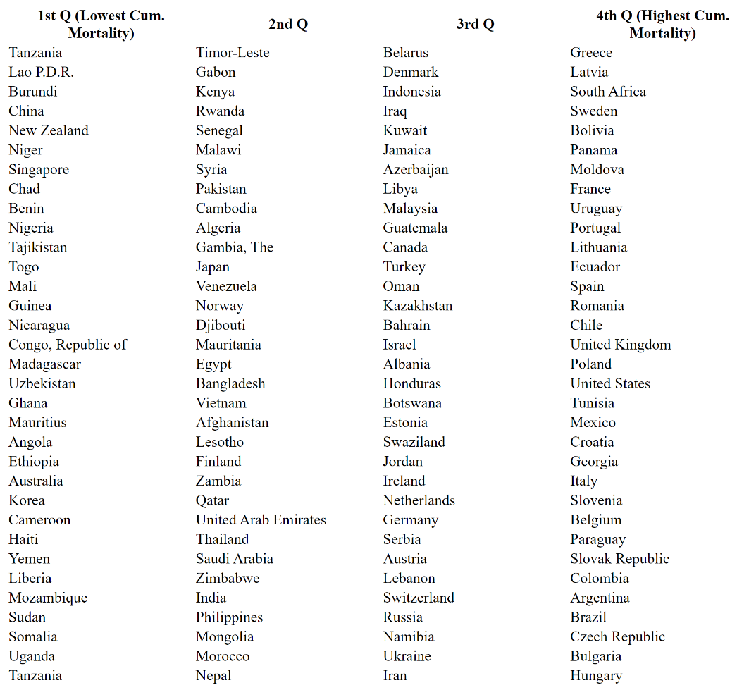

Question: Tanzania appears as BOTH the lowest and the highest mortality country within the lowest mortality/capita quartile. This obviously has to be corrected

Contrasting the Quartiles of Cumulative Confirmed Covid Mortality per million average county’s characteristics in December 2021 (Table 2a) with the Quartiles of Cumulative Excess Mortality per million in December 2021 (Table 2b) revels disturbing fundamental differences between these two data sets.

The Cumulative Confirmed Covid Mortality table indicates that higher GDP/capita countries preformed badly relative to the low- and middle-income countries. The lowest mortality quartile average GDP/capita is 1/4 of the higher mortality quartile. The second worst preforming quantile average GDP/Capita exceed that GDP/Capita of the second-best performing quantile by about 1/5. Similar observations apply for measures of institutional quality. The best preforming quartile average health expenditure was 1/8 of that of the worst preforming quartile; the rule of law, the voice and accountability, and government effectiveness are ranked significantly higher for the worst preforming quartile.

Intriguingly, almost the opposite patterns characterize the Quartiles of Cumulative Excess Mortality. The lowest excess mortality quantile average income/capita is the highest ($ 25,293), while the second-best preforming quartile has the lowest average income/capita, less than half of the best preforming quartile. The worst excess mortality quartile’s average income/capita is 3/5 of the average income/capita of the best preforming quartile. The quartile with the lowest excess mortality is characterized by best rule of law, voice and accountability, and government effectiveness.

These observations raise fundamental concerns about the quality of cumulative mortality data in Covid times. It also challenges simplistic interpretations and generalizations, like the notion that on average, OECD countries failed in dealing with Covid challenges relative to low- and middle-income countries. This view is possibly in line with the Quartiles’ average statistics of Confirmed Covid Mortality, but is mostly rejected by excess mortality data. The sharp contrast between the two tables maybe in line with the conjecture that countries ranked higher in terms of rule of law, voice and accountability and government effectiveness are also countries where the gap between the confirmed covid mortality and the excess mortality is smaller. [3] **Weining and Yo: please test this and related assertions**

Table # provides the estimation of cumulative excess/official COVID-19 death ratios (henceforth, E/O) on the level of income (as measured by GDP per capita) and the level of vaccination (the share of people (per hundred) fully vaccinated against COVID-19) across 170 countries for 2020 and 2021. The first column shows that, at the end of 2020, the association between E/O and GDP per capita is negative but statistically insignificant. In 2021, however, as COVID-19 vaccine became widely available throughout the year, the associations between cumulative E/O and GDP per capita, as well as with the level of vaccination, have become negative and statistically significant in the international sample.

|  |  |  |
| --- | --- | --- |
| Table #. Cumulative Excess/Official COVID-19 Death Ratios across Countries, 2020 and 2021. | | |
|  | As of 2020-12-28 | As of 2021-12-27 |
| GDP per Capita | -1.34 | -0.37** |
|  | (0.92) | (0.12) |
| Vaccination |  | -0.26*** |
|  |  | (0.07) |
| Constant | 57.01 | 29.32*** |
|  | (37.61) | (7.18) |
| F-stats | 2.1 | 7.9 |
| R-squared | 0.01 | 0.08 |
| Countries | 170 | 170 |
| Vaccination is the share of people (per hundred) fully vaccinated against COVID-19. Excess Deaths (per million population) are from the Economist; Official Deaths (per million population) from COVID-19 and Vaccination from Our World in Data. GDP per Capita (thousands) is based on purchasing power parity (PPP) International Comparison Program (ICP).  Robust standard errors are in parenthesis.  * p<0.05, ** p<0.01, *** p<0.001 | | |

**References**

Acemoglu, D., Chernozhukov, V., Werning, I., & Whinston, M. D. (2021). Optimal targeted lockdowns in a multigroup SIR model. *American Economic Review: Insights*, *3*(4), 487-502.

Aizenman, J., Cukierman, A., Jinjarak, Y., & Xin, W. (2021). International Evidence on Vaccines and the Mortality to Infections Ratio. National Bureau of Economic Research, NBER Working papers No. w29498.

Kendall DG (1956). ["Deterministic and stochastic epidemics in closed populations"](http://projecteuclid.org/euclid.bsmsp/1200502553). Proceedings of the Third Berkeley Symposium on Mathematical Statistics and Probability: Contributions to Biology and Problems of Health. 4: 149–165

Kermack, William Ogilvy, A. G. McKendrick, and Gilbert Thomas Walker, (1927). “A contribution to the mathematical theory of epidemics,” Proceedings of the Royal Society of London. Series A, Containing Papers of a Mathematical and Physical Character, 115 (772), 700–721.

1. Higher income/capita may be associated with exacerbated Covid challenges in countries with greater political, income or ethnic polarization where the pandemic hits disproportionately lower income households and marginalized groups. See Van Bavel, J. J., Baicker et al. (April, 2020). [Using social and behavioural science to support COVID-19 pandemic response](https://www.nature.com/articles/s41562-020-0884-z). *Nature Human Behaviour*, 1-12. for overview of social, behavioral and political dimensions of pandemics.
2.
3. Similar, possibly even sharper inferences apply to the contrast between the Tables dealing with the first covid year, Table 1a and 1b. Indeed, in the first Covid year, GDP/Capita, rule of law, voice and accountability, and government effectiveness were higher and better for the worst preforming quartiles (see Table 1a). This may be in line with the faster distribution of effective vaccines in the OECD countries during the second year, narrowing the gap between confirmed covid mortality and excess mortality in the OECD versus the low- and middle-income countries.